# CHAPTER – 1 INTRODUCTION

## 1.1 Introduction to project

In an era marked by technological innovation, the pursuit of inclusivity drives the development of assistive devices tailored to the needs of diverse user groups. Among these, individuals who are both blind and deaf face unique challenges in navigating their environment independently. To address this, our project focuses on the creation of a wearable assistive device, seamlessly integrating cutting-edge technology into sunglasses. By harnessing the power of an Arduino Nano, ultrasonic sensor, sound detector module, and vibration motor, our device aims to provide real-time environmental feedback to users, enhancing their mobility and safety.

The core functionality of our wearable assistive device revolves around its ability to detect obstacles and environmental sounds, crucial for the navigation and situational awareness of blind and deaf individuals. The ultrasonic sensor serves as the primary means of obstacle detection, relaying information to the Arduino Nano, which in turn activates the buzzer mounted on the sunglasses to alert the user. Additionally, the sound detector module enhances the device's capabilities by detecting ambient sounds such as emergency sirens or speech, triggering the vibration motor mount to further alert the user. Designed with wearability in mind, our device integrates seamlessly into sunglasses, empowering users to maintain their mobility while remaining aware of their surroundings. Through this innovative approach, our project holds the potential to significantly enhance the independence and safety of blind and deaf individuals in their daily lives, paving the way for a more inclusive society.

In the rapidly evolving landscape of technological innovation, a relentless commitment to inclusivity emerges as a guiding principle, propelling the development of assistive devices meticulously tailored to meet the diverse and intricate needs of user groups worldwide. Among these communities, individuals who navigate the world with the dual challenges of blindness and deafness confront a profound and unique set of obstacles, underscoring the urgent need for innovative solutions to empower their independence and enhance their quality of life.

Enter our pioneering project, poised at the forefront of assistive technology, dedicated to the creation of a revolutionary wearable device seamlessly integrated into the familiar and universally recognized form of sunglasses. Harnessing the transformative potential of cutting- edge components such as the Arduino Nano microcontroller, ultrasonic sensor technology, advanced sound detection modules, and precision-engineered vibration motors, our device represents a quantum leap forward in the realm of assistive technology, promising to redefine the boundaries of mobility and safety for individuals with dual sensory impairments.

At its core, our wearable assistive device embodies a seamless fusion of form and function, combining sleek aesthetics with unparalleled functionality to deliver real-time environmental feedback to its users. With an unwavering focus on user-centric design principles, our device empowers individuals facing the challenges of blindness and deafness to navigate their surroundings with confidence, independence, and dignity.

Central to the functionality of our ground breaking device is its unparalleled capacity to detect and interpret environmental cues essential for safe and independent navigation. Leveraging the power of ultrasonic sensor technology, our device stands poised to identify and alert users to potential obstacles in their path, ensuring timely intervention and mitigating the risk of accidents or collisions. Through seamless integration with the Arduino Nano microcontroller, our device orchestrates a symphony of sensory inputs, translating raw data into actionable insights and empowering users with the information they need to navigate their surroundings with ease.

Furthermore, our device augments its obstacle detection capabilities with advanced sound detection modules, enabling it to discern and interpret ambient sounds with remarkable precision. From the piercing wail of emergency sirens to the soothing cadence of human speech, our device stands ready to alert users to the presence of auditory cues that may otherwise go unnoticed, ensuring heightened situational awareness and bolstering their confidence in navigating complex and dynamic environments.

Yet, perhaps the most remarkable aspect of our wearable assistive device lies in its seamless integration into the familiar form of sunglasses, transcending the traditional boundaries of assistive technology to deliver a truly transformative user experience. Crafted with an unwavering commitment to comfort, style, and wear ability, our device represents a bold departure from conventional assistive devices, offering users a discreet and dignified meansof accessing the support they need to navigate the world on their own terms.

# CHAPTER – 2 LITERATURE REVIEW

## 2.1 Related works

**Ankush yadav.al** presented a paper on 2022[1] titled Arduino based third eye for blind people this is the wearable invention for the weak and blind people they don’t need to carrying anything in hand while walking they should only wear our invention and used to get walking easily. The Arduino is a software device which include. coding as a software function and Ultrasonic sensor, buzzer, Battery and more things as a hardware function, Ultrasonic sensor has a work to recognize the object near them and providing the signal via buzzer to the user which help the person to reach properly at their destination. Main Term: Arduino Uno module, Vibration, Ultrasonic sense.

**Khan Irfan ali sultan .al** presented a paper on 2022[2] titled third eye for blind will help navigate them though streets, meetings , surroundings etc. we tried to keep in budget so its affordable to everyone. Its work on ultrasound sensor system , it detect the distance of the object . it works by sending ultrasound and then sensing the reflected rays and thus determine the distance. By using Arduino as microprocessor and buzzer for giving feedback output .

**Samartha koharwal.al** presented a paper on 2019[3] titled navigation system for blind person Visually impaired individuals with severe conditions struggle with independent movement, often leading to disadvantages in today's fast-paced world. While traditional methods like guide dogs or canes offer limited assistance, RFID- based guidance systems face outdoor usage constraints. This paper introduces an AI- powered navigation system called "Third Eye," offering an economical, dependable solution using IR, sonar, and camera sensors. Classifying frontal obstacles, this wearable system (attachable to a hat or small handstick) enhances self reliance for visually impaired users both indoors and outdoors.

**Lamya Albraheem.al** presented a paper on 2015[4] titled third eye There are numerous challenges faced by visually impaired individuals in carrying out their daily activities, such as distinguishing between similar-looking objects or understanding menu options. Recently, there has been increasing interest in creating practical solutions to aid the blind in object recognition. However, most queries from visually impaired people remain inaccessible to automated methods. Moreover, there

is a notable lack of programs tailored to Arabic- speaking blind users. To tackle all these issues, a feasible solution is required that allows Arabic-speaking blind individuals to recognize any object, regardless of location, without any restrictions. Therefore, the proposed plan is to create an effective system that can facilitate object recognition for Arabic-speaking blind persons.

# CHAPTER – 3 PROJECT DESCRIPTION

## Title of the project

The title of the project is “**Assistive device for blind and deaf people**” Is an innovative project aimed at enhancing accessibility for individuals with visual and auditory impairments. Leveraging the power of Arduino Nano microcontrollers and a suite of sensor technologies, including ultrasonic sensors, sound detector modules, buzzers, and vibration motors, Assistive device for blind and deaf people offers a comprehensive solution. By utilizing ultrasonic sensors, the device provides real-time distance feedback, enabling individuals with visual impairments to navigate their surroundings safely. Additionally, integrated sound detector modules alert users to important auditory cues, while buzzers and vibration motors provide tactile feedback for enhanced awareness.

## Objectives

* To develop a sound sensor system capable of detecting surrounding sound and translating it into vibrations as an output signal.
* To utilize ultrasonic sensors for the purpose of detecting obstacles.
* To adjust the output of beeps and vibrations from individual ultrasonic sensors for obstacle detection and sound sensor for vibrations.
* To integrate stereo mode within the device to enhance sound detection capabilities, thereby improving the precision of vibration output for enhanced obstacle detection.
* To develop a wearable device that can be comfortably worn by individuals for convenient use and portability.

## Description

The project endeavours to develop a transformative wearable assistive device tailored for individuals who grapple with both visual and auditory impairments. By harnessing the capabilities of cutting-edge technology such as the Arduino Nano, ultrasonic sensors, sound detection modules, and vibration motors, this innovation promises to be a beacon of independence and safety in the daily lives of the blind and deaf community. The core functionality of the device revolves around its integration into sunglasses, where the ultrasonic sensor acts as a vigilant guardian, detecting obstacles in the user's path and seamlessly relaying signals to the Arduino Nano. Upon detection, the Arduino swiftly activates a buzzer mounted on the sunglasses, alerting the wearer to potential hazards and facilitating obstacle avoidance.

The assistive device integrates an Arduino Nano, ultrasonic sensor, buzzer, sound detector module, and vibration motor to aid blind and deaf individuals in navigating their environment. It operates by constantly emitting ultrasonic waves from the sensor and calculating the distance to any obstacles detected. When an obstacle is within a predetermined range, the Arduino triggers the buzzer, emitting a sound alert to the user.

Concurrently, the sound detector module picks up environmental sounds, such as approaching vehicles or people speaking. If a sound is detected, the Arduino activates the vibration motor, providing tactile feedback to the user. This combination of auditory and tactile cues enables individuals with visual and auditory impairments to safely navigate their surroundings, enhancing their independence and mobility.

And all the components used in this project is mounted on the sunglasses which is wearable and good for both the individual visual impaired and hearing impaired person . The Arduino gets power supply from the lithium ion battery which is in good power backup condition. And the sound detector module sensitivity is adjustable according to the need of the impaired person for the best haptic feedback . All of this things and the components are used in this project

Moreover, the device does not solely rely on visual cues but also incorporates auditory alerts through the sound detector module. This component is adept at discerning environmental sounds, ranging from critical signals like emergency sirens to spoken communication. Upon detection, the sound detector module swiftly communicates with the vibration motor mount integrated into the sunglasses, ensuring that the wearer receives timely and discreet alerts. By synergizing these functionalities, the wearable device empowers individuals with dual sensory impairments to navigate their surroundings confidently while fostering a heightened sense of awareness and safety. In essence, this project represents a remarkable stride towards inclusivity, promising to significantly enhance the quality of life for those with visual and auditory challenges.

## Software Used

The Arduino IDE (Integrated Development Environment) is a software platform designed to simplify the process of writing, compiling, and uploading code to Arduino boards. It provides a user-friendly interface that allows developers, hobbyists, and students to quickly prototype and develop projects using Arduino-compatible micro- controllers.

* **Key features of the Arduino IDE include:**
  + **Code Editor:** The IDE offers a simple yet powerful code editor with syntax highlighting, auto-indentation, and code completion features, making it easier to write and edit Arduinosketches (programs).
  + **Library Manager:** Arduino IDE includes a library manager that allows users to easily install and manage libraries (collections of pre-written code) to extend the

functionality of their projects. This feature simplifies the integration of sensors, displays, communication modules, and other peripherals into Arduino projects.

* + **Board Manager:** Arduino IDE supports a wide range of Arduino-compatible boards. The board manager allows users to install additional board definitions, enabling support for various micro-controllers and development boards beyond the official Arduino line-up.
  + **Serial Monitor:** The IDE includes a built-in serial monitor tool that allows users to communicate with their Arduino boards via the serial port. This feature is invaluable for debugging code and monitoring the output of sensors or other peripherals connected to theboard.
  + **Upload and Compilation:** Arduino IDE streamlines the process of compiling and uploading code to Arduino boards. With just a few clicks, users can compile their sketches and uploadthem to the connected Arduino board via USB or other supported interfaces.
  + **Examples and Tutorials:** The IDE comes with a collection of example sketches and tutorials covering various aspects of Arduino programming. These resources help user learn the basics of Arduino programming and explore different functionalities and capabilities of Arduino boards.

To upload sketches in Arduino IDE, following are the steps that need to be followed**.**

* + Open Arduino IDE
  + Connect the board to your computer
  + Board package installation
  + Select board and port
  + Upload a sketch



Fig. 3.1; Arduino Logo

## Opening Arduino IDE

First, we downloaded Arduino IDE and opened the application

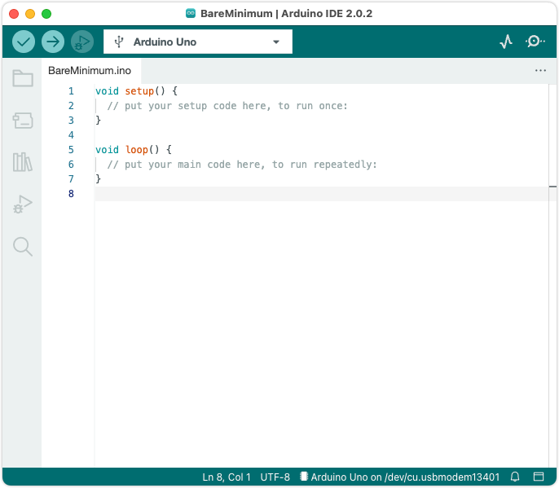

Fig 3.2;Open Arduino IDE Software

## Connect the board to the computer

Next, connect the board to the computer with a USB cable. This will both

power the board and allow the IDE to send instructions to the board. We need a data

USB cable (a charge-only cable will not work), with connectors that fit both the

board and computer.Arduino boards use different USB connectors:

USB-B (UNO Rev3, UNO WiFi Rev2, Mega boards) Mini-B USB (Nano)

Micro-B (Nano Family boards (except the classic Nano), MKR Family boards)

USB-C (Portenta boards, UNO Mini Limited Edition)

## Installing board package

To compile and upload sketches for your board Arduino IDE needs a collection of filesfor that board called a board package.

When Arduino IDE detects a board with a missing board package, it may ask you toinstall the missing files:

In IDE 1, click Install this package:



## Upload a Sketch

Fig 3.3;Installation of package

* + - * Write a sketch, or use an Example such as Blink (*File> Example>0.1Basics> Blink*).
      * Optional: Click the  Verify button to try compiling the sketch andcheck for errors.
      * Click the  Upload button to program the board with the sketch.

## Hardware Used

* Arduino Nano
* Ultrasonic sensors
* Sound Detector Module
* Vibration Motors
* Lithium Ion Battery
* Jumper Wires
* Switch

## Arduino Nano

The Arduino Nano is a miniature yet powerful micro-controller board designed for projects with limited space constraints. Despite its compact size of approximately 45mm × 18mm, itboasts a remarkable array of features. Sporting the ATmega328P micro-controller, it offers

14 digital input/output pins, 8 analog inputs, and PWM capabilities on select pins. This versatility makes it suitable for a wide range of applications, from robotics to wearable electronics. Its USB interface facilitates easy programming and serial communication with computers via the Arduino IDE.

With itsaffordability, ease of use, and broad compatibility, the Arduino Nano has earned its place as a favourite tool among hobbyists, students, and professionals alike.

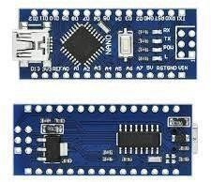

Fig 3.4; Arduino Nano

## Ultrasonic Sensor

The ultrasonic sensor serves as the vigilant eye of the wearable assistive device, meticulously scanning the user's surroundings to detect potential obstacles with remarkable precision. Utilizing high-frequency sound waves, it gauges the distance between the wearer and objects in their path, offering real-time feedback to ensure seamless navigation. Its ability to swiftly and accurately identify obstacles enables the device to provide timely alerts, mitigating the risk of collisions and promoting the user's safety and independence. Integrated seamlessly into the sunglasses, the ultrasonic sensor operates discreetly, without impeding the wearer's mobility or comfort. In essence, the ultrasonic sensor acts as a crucial sensory extension, empowering individuals with visual impairments to navigate the world with confidence and ease.

Furthermore, the ultrasonic sensor's integration into the wearable device epitomizes seamless design and user-centric innovation. Mounted discreetly within the sunglasses, it remains unobtrusive while delivering invaluable assistance to the wearer. This integration not only enhances the device's aesthetic appeal but also underscores its practicality and utility in everyday life.

Additionally, the sensor's low power consumption and compact form factor contribute to the overall efficiency and portability of the device, facilitating prolonged usage without compromising on performance.

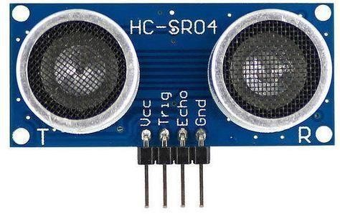

Fig 3.5; Ultrasonic sensor

Beyond its technical prowess, the ultrasonic sensor symbolizes a beacon of empowerment for individuals with visual impairments. By equipping users with real-time spatial awareness and obstacle detection capabilities, it fosters a sense of autonomy and confidence in navigating diverse environments. Moreover, the sensor's role in the wearable device exemplifies the transformative potential of assistive technologies in promoting inclusivity and accessibility for all. In essence, the ultrasonic sensor represents not only a technological marvel but also a catalyst for positive change, enriching the lives of those it serves with newfound independence and freedom of movement.

## Sound Detector Module

The sound detector module within the wearable assistive device stands as a crucial component, offering an additional layer of awareness and safety for individuals facing visual and auditory challenges. This module operates by capturing ambient sounds in the user's environment, ranging from emergency sirens to spoken communication, and swiftly translating them into actionable alerts. Its sophisticated audio detection capabilities enable it to distinguish between various types of sounds, ensuring that the wearer receives pertinent information in real-time. Integrated seamlessly into the device, the sound detector module complements the functionality of the ultrasonic sensor, providing comprehensive situational awareness to enhance the user's navigation experience.

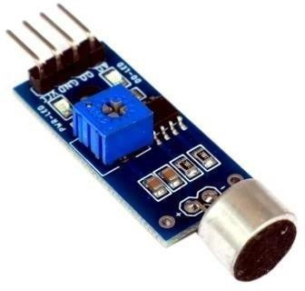

Fig 3.6; Sound Detector Module

Moreover, its discreet presence within the sunglasses underscores the device's user-centric design, prioritizing both functionality and comfort. By harnessing the power of sound detection technology, this module empowers individuals with visual and auditory impairments to engage with their surroundings confidently and independently, fostering a newfound sense of freedom and security in their daily lives.

## Vibration Motors

Vibration motors are compact yet powerful devices designed to create controlled vibrations in various electronic devices and applications. Typically small in size, these motors are often cylindrical or coin-shaped and utilize eccentric weights or mechanisms to generate vibration when activated. They are commonly employed in a wide range of consumer electronics, industrial machinery, and haptic feedback systems. In smartphones, for instance, vibration motors play a crucial role in providing tactile feedback for notifications, alerts, and haptic interactions, enhancing user experience by simulating the sensation of pressing physical buttons or navigating virtual interfaces.

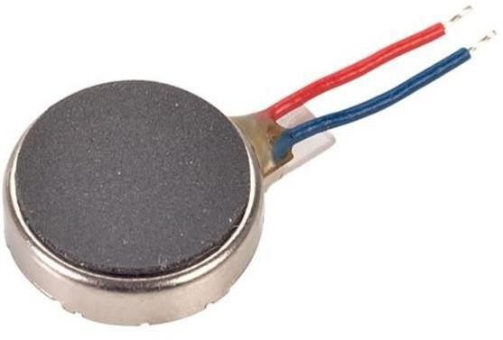

Fig. 3.7; Vibration Motors

Beyond smartphones, they are integral components in video game controllers, wearable devices, and automotive systems, contributing to immersive gaming experiences, health monitoring functionalities, and tactile feedback in vehicle interfaces. Industrial applications of vibration motors include material handling equipment, conveyor systems, and vibration testing apparatus, where they are utilized for conveying, sieving, and quality control purposes. Additionally, vibration motors find application in medical devices such as vibrating massagers and therapeutic tools, aiding in pain relief and muscle relaxation. The versatility and efficiency of vibration motors make them indispensable in modern technology, enabling enhanced user interaction, improved functionality, and innovative design across various industries and applications.

## Lithium Ion Battery

Lithium-ion batteries (Li-ion) stand at the forefront of portable power solutions, revolutionizing the landscape of energy storage in countless applications across industries. Characterized by their high energy density, lightweight design, and rechargeable nature, Li- ion batteries have become the go-to choice for powering everything from smartphones and laptops to electric vehicles and grid-scale energy storage systems. At the heart of a Li-ion battery is an electrochemical cell composed of positive and negative electrodes separated by an electrolyte, typically a lithium salt dissolved in a solvent. During discharge, lithium ions move from the negative electrode (anode) through the electrolyte to the positive electrode (cathode), generating electrical energy that can be used to power devices. Rechargeability is facilitated by the reverse flow of ions during charging, replenishing the battery's energy stores.

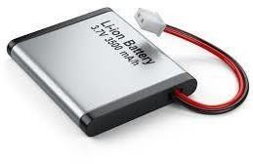

Fig. 3.8; Lithium Ion Battery

The choice of electrode materials significantly influences the performance characteristics of Li-ion batteries, with advancements in materials science continually driving improvements in

energy density, cycling stability, and safety. Graphite and various forms of lithium metal

oxides, such as lithium cobalt oxide, lithium iron phosphate, and lithium manganese oxide, are commonly used in commercial Li-ion batteries. The proliferation of electric vehicles (EVs) and renewable energy technologies has spurred intense research and development efforts aimed at further enhancing the performance and reducing the cost of Li-ion batteries.

Innovations in battery chemistry, manufacturing processes, and recycling techniques hold the promise of ushering in a new era of sustainable energy storage, facilitating the transition to a cleaner, electrified future. However, challenges remain, including concerns over resource availability, safety risks associated with thermal runaway events, and the environmental impact of battery production and disposal. Addressing these challenges will be crucial in realizing the full potential of Li-ion batteries as a cornerstone of the global energy ecosystem, enabling widespread adoption of clean energy technologies and driving the transition towards a more sustainable and electrified future.

## Jumper Wires

Jumper wires are the unsung heroes of electronics prototyping, serving as the indispensable conduits that connect various components on breadboards or circuit boards. These slender, flexible wires, typically with metal pins at each end, facilitate the seamless transfer of electrical signals between different points in a circuit, enabling engineers, hobbyists, and students to build and test their electronic designs with ease and precision. Whether used to bridge connections between components, create complex circuits, or troubleshoot wiring issues, jumper wires offer unparalleled versatility and convenience. Available in a range of lengths, colors, and gauges, they provide users with the flexibility to customize and optimize their circuit layouts according to their specific needs and preferences. With their simplicity, affordability, and reliability, jumper wires are an essential tool in the arsenal of anyone venturing into the captivating realm of electronics experimentation and innovation.

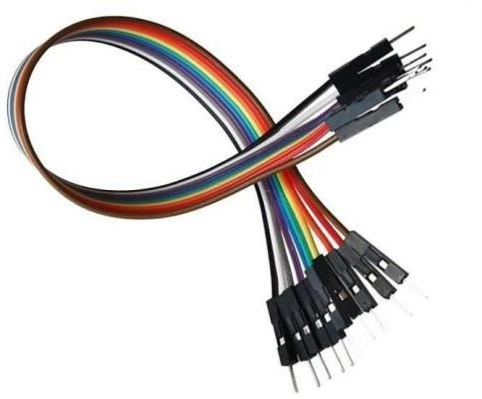

Fig 3.8; Jumper Wires

## Switch

Switches are fundamental components in electrical circuits, serving as gatekeepers that control the flow of current. Whether in the form of a simple toggle switch, a push-button switch, or a more sophisticated rotary or slide switch, these devices play a pivotal role in a wide array of applications, from household appliances to industrial machinery. A switch consists of movable contacts that can be opened or closed, thereby interrupting or completing the circuit. This functionality enables users to turn devices on or off, change their operating modes, or trigger specific actions with precision and ease. With their versatility and reliability, switches empower users to exert control over electrical systems, ensuring safety, efficiency, and functionality in countless everyday scenarios. From light switches illuminating rooms to power switches activating machinery, switches are the silent guardians of modern electrical infrastructure, quietly facilitating our interconnected world.

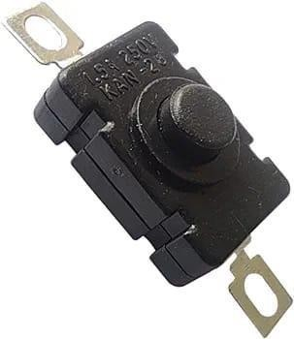

Fig 3.10; Switch

## Charging Module

A charging module is an essential component in various electronic devices, designed to replenish their power reserves efficiently and safely. It typically consists of circuitry and hardware that manage the flow of electricity from a power source to the device's battery, ensuring optimal charging conditions. These modules come in diverse forms, ranging from simple USB chargers to advanced wireless charging pads. They employ various technologies such as fast charging, Qi wireless charging, and adaptive charging algorithms

to accommodate different devices and battery types. The primary function of a charging module is to provide convenience and reliability, allowing users to effortlessly power up their devices while safeguarding them against overcharging, overheating, and other potential risks.

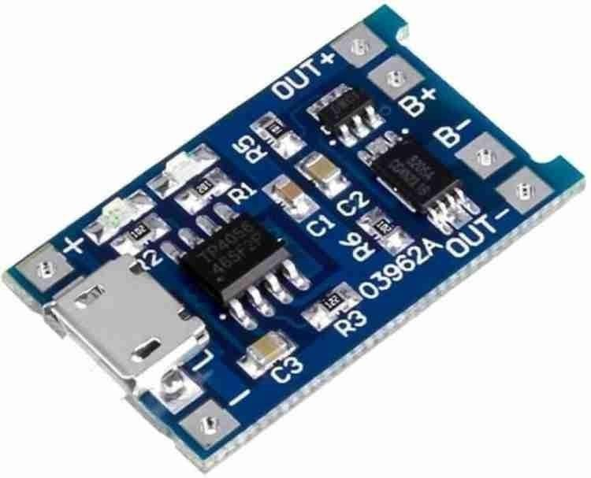

Fig 3.11; Charging Module

The functioning of a charging module involves several key stages to ensure effective and safe charging of electronic devices or batteries. Firstly, it regulates the incoming power supply, whether from a wall socket, USB port, or another source, to ensure compatibility with the device's battery specifications. This may involve converting alternating current (AC) to direct current (DC) or stepping up/down voltage levels as needed.

Once the power is conditioned, the charging module manages the charging process itself. This includes monitoring the battery's current state, such as its charge level and temperature, to apply the appropriate charging algorithm. For instance, it may employ constant current charging initially to rapidly charge the battery until it reaches a certain voltage level, followed by constant voltage charging to top it off while minimizing stress on the battery cells.

Throughout the charging process, the module implements safety measures to protect both the device and the user. This may involve safeguards against overcharging, overheating, short circuits, and other potential hazards. For example, the module may automatically reduce charging current or shut off entirely if it detects abnormal conditions that could pose a risk.

## Project Specification

|  |  |  |
| --- | --- | --- |
| **S NO.** | **Hardware Used** | **Specifications** |
| **1** | **Arduino-Nano** | * Microcontroller: ATmega328P Operating * Voltage: 5 volts * Input Voltage (recommended): 7-12 volts * Input Voltage (limit): 6-20 volts * Digital I/O Pins: 14 (of which 6 provide PWM output) * Analog Input Pins: 8 * DC Current per I/O Pin: 40 mA DC Current for   3.3V Pin: 50 mA   * Flash Memory: 32 KB (of which 2 KB is used by the bootloader) * SRAM: 2 KB * EEPROM: 1 KB * Clock Speed: 16 MHz * Length: 45 mm * Width: 18 mm * Weight: 5 grams |
| **2** | **Ultra Sonic Sensor** | * Emit high-frequency sound waves. * Measure reflected wave time for object detection. * Range: cm to meters. * Frequency: 20 kHz to 200 kHz. * Output: Analog/digital signal or communication protocol. * Low power consumption. |
| **3** | **Buzzer** | * Voltage: Typically 3-12V. * Current: Usually a few mA to 30mA. * Sound: Output in decibels (dB). * Pattern: Continuous or pulsating tones. * Size: Various sizes available. * Durability: Resistant to temperature, humidity, and vibration. * Activation: Triggered by applying voltage. * Mounting: Can be soldered or mounted with holes. |
| **4** | **Sound Detector Module** | * Voltage: Typically 3.3V to 5V. * Detection Range: Adjustable. * Output: Digital or analog signal. * Frequency Response: 20 Hz to 20 kHz. * Detection Method: Microphone or piezoelectric element. * Response Time: Fast. * Size: Compact. |

18

|  |  |  |
| --- | --- | --- |
| **5** | **Vibration Motors** | * Voltage: Typically 1.5V to 5V. * Amplitude: Varies in millimeters. * Frequency: Typically tens to hundreds of Hertz. * Current: Low consumption. * Form: Various sizes and shapes. * Drive: DC or PWM signals. * Construction: ERM or LRA mechanism. * Applications: Haptic feedback, alerts. |
| **6** | **Lithium Ion Battery** | * Voltage: Typically 3.7 volts per cell. * Capacity: Measured in mAh or Ah. * Chemistry: Lithium-ion chemistry. * Rechargeability: Can be recharged hundreds to thousands of times. * Form Factor: Various shapes and sizes available. * Weight: Lightweight. * Energy Density: High energy storage per unit weight or volume. * Voltage Stability: Relatively stable during discharge. * Safety: Generally safe if handled properly. * Applications: Used in portable electronics, electric vehicles, and energy storage systems. |
| **7** | **Switch** | * Function: Controls electrical current flow. * Types: Toggle, rocker, push button, etc. * Poles/Throws: Controls circuits/positions. * Voltage/Current: Maximum handling capacity. * Contact Rating: Max current/voltage without damage. * Temperature: Operating range. * Durability: Number of cycles before failure. * Mounting: Panel, PCB, or soldered. * Actuation: Press, flip, slide, turn. * Applications: Used for control and power management. |
| **8** | **Range of Ultrasonic and Sound of Buzzer according**  **to the Distance** | * If distance is too less than the buzzer will beeps fastly. * If the distance is increasing then the buzzer will   beeps with a delay depending on the distance. |

# CHAPTER – 4 METHODOLOGY

## Methodology of Project

* + - **Understanding User Needs**: Begin by researching and understanding the needs and challenges faced by blind and deaf individuals. This could involve interviews, surveys, or consulting with relevant organizations or experts in the field. To effectively address the needs of blind and deaf individuals in the development of an assistive device, comprehensive research and understanding of their challenges are paramount. This involves engaging in interviews, surveys, and consultations with relevant organizations or experts in the field of assistive technology and disability advocacy. By directly interfacing with the target user group, we aim to gain insights into the specific obstacles encountered in navigating their environment, interpreting auditory cues, and accessing information. Through this process, we seek to identify the key functionalities and features that would enhance independence, safety, and communication for individuals with combined visual and auditory impairments. These insights will inform the design and development of our assistive device, ensuring it addresses the unique needs and preferences of the end-users effectively.
    - **Define Device Objectives**: Clearly define the objectives of the assistive device.
      * To develop a sound sensor system capable of detecting surrounding sound and translating it into vibrations as an output signal.
      * To utilize ultrasonic sensors for the purpose of detecting obstacles.
      * To adjust the output of beeps and vibrations from individual ultrasonic sensors for obstacle detection and sound sensor for vibrations.
      * To integrate stereo mode within the device to enhance sound detection capabilities, thereby improving the precision of vibration output for enhanced obstacle detection.
      * To develop a wearable device that can be comfortably worn by individuals for convenient use and portability.
* **Component Selection**: Select the necessary components for the project, including:
  + **Arduino Nano**: For controlling the device and processing sensor data.
  + **Ultrasonic sensor**: For detecting obstacles in the environment.
  + **Sound detector module**: For detecting auditory signals.
  + **Vibration motors**: For providing haptic feedback to the user.
  + **Sunglasses**: To mount the all the hardware and create a wearable device.
* **Circuit Design**: Design the circuitry to connect all components to the Arduino Nano. Consider power requirements, sensor interfaces, and connections for the vibration motors.

ULTRASONIC SENSOR

input

ARDUINO NANO

output

BUZZER

Fig 4.1; Block Diagram of Assistive Device

* **Programming:** Write the code for the Arduino Nano to control the device. This involves:

input

output

VIBRATIONS MOTORS

SOUND DETECTOR MODULE

* + Reading data from the ultrasonic sensor to detect obstacles.
  + Monitoring sound input from the sound detector module.
  + Processing sensor data to determine appropriate feedback for the user.
  + Controlling the vibration motors to provide feedback based on sensor inputs.
* **Optimization:** In the optimization phase of our project focusing on the development of an assistive device for blind and deaf individuals, we will prioritize enhancing the device's portability, comfort, and practicality as sunglasses. This will involve careful consideration of the size and weight of the components to minimize bulkiness and ensure ease of wearability. Additionally, we will explore strategies to minimize power consumption, potentially through the use of efficient power management techniques or low-power components. Ensuring user comfort is paramount, and we will seek to

achieve this by designing the device in a manner that distributes weight evenly and avoids causing discomfort or fatigue during prolonged use. By refining the design and form factor, we aim to create a portable and discreet solution that seamlessly integrates into the user's daily life, empowering them to navigate their environment with greater autonomy and confidence.

* **Deployment and Feedback**: In the deployment and feedback phase of our project, centered on the development of an assistive device for individuals who are blind and deaf, we will roll out the final version of the device to users. This deployment will involve placing the device in the hands of individuals from our target demographic to gather insights into its long-term usability and effectiveness in real-world scenarios. Through ongoing interaction and feedback sessions, we will actively solicit input from users to identify areas for improvement and refinement. This iterative process will enable us to iteratively enhance the device's design and functionality based on user feedback and emerging technological advancements. By maintaining a collaborative and user-centered approach, we aim to continually evolve the device to better meet the evolving needs and preferences of individuals with combined visual and auditory impairments, ultimately maximizing its impact and utility in enhancing their quality of life.

# CHAPTER-5 RESULT AND DISCUSSION

## Steps to followed to obtained the project:

* + - **Understanding the Requirements:** Begin by thoroughly understanding the needs of blind and deaf individuals and how your device can address them. Consider factors such as navigation, obstacle detection, communication, and feedback mechanisms.

To design an assistive device for blind and deaf people using Arduino Nano, ultrasonic sensor, buzzer, sound detector, and vibration motor, the first step is to establish the basic functionality and user interaction requirements. This entails understanding the challenges faced by individuals with visual and auditory impairments and determining how the selected components can address these challenges effectively.

* + - **Component Selection and Integration:** Choose appropriate components for your project, ensuring compatibility and functionality. For instance, select an Arduino Nano as the microcontroller, ultrasonic sensor for obstacle detection, buzzer for auditory feedback, sound detector for detecting environmental sounds, and vibration motor for tactile feedback.With the components identified, the next step involves integrating them into a cohesive system. This includes wiring the components to the Arduino Nano, ensuring proper connections and compatibility between the various modules.
    - **Programming the Arduino:** Develop the code to control the functionality of the device. This involves programming the Arduino Nano to read input from the ultrasonic sensor and sound detector, process the data, and trigger appropriate responses such as activating the buzzer or vibration motor based on detected obstacles or sounds.Programming the Arduino Nano involves writing code that defines the behavior of the device in response to different inputs and conditions. This includes setting up the ultrasonic sensor to measure distances, configuring the sound detector to recognize specific sounds or frequencies, and defining the logic for generating auditory and tactile feedback.
    - **Testing and Iteration:** Test the device thoroughly to ensure it functions as intended and meets the needs of the target users. Iterate on the design and code as necessary based on user feedback and testing results.

Testing the device involves conducting real-world trials with blind and deaf

individuals to evaluate its effectiveness in assisting with navigation, obstacle detection, and communication. This may involve simulated scenarios or controlled environments to assess different aspects of the device's performance.

* + - **Refinement and Optimization**: Refine the design and code to improve usability, reliability, and performance. Optimize the device to minimize power consumption, enhance responsiveness, and address any identified issues or limitations.Refinement and optimization are ongoing processes aimed at enhancing the overall functionality and user experience of the device. This may involve revising the hardware design, fine- tuning the software algorithms, or incorporating additional features based on user feedback and evolving needs.

## Project Outputs:

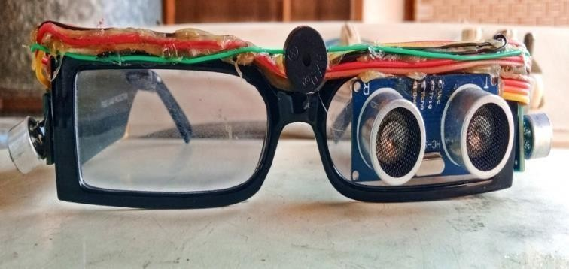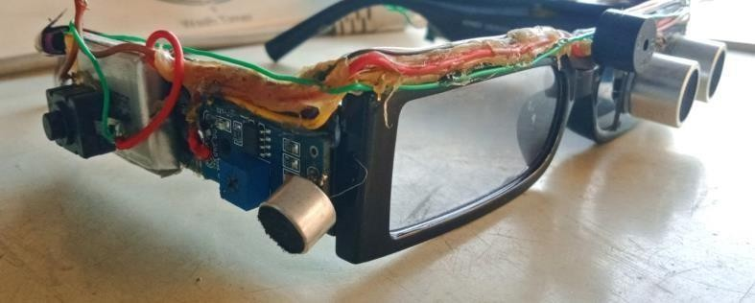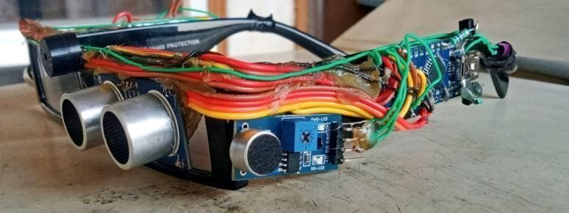

**(B)(Sound Detector Module on right side)**

**(C)(Sound Detector Module on left side)**

**(A)(Ultrasonic sensor)**

Fig 5.1; Project Output

# CHAPTER-6 APPLICATIONS & ADVANTAGES

**6.1 Applications**

* **Navigation Aid**: Helps blind users avoid obstacles by alerting them with vibrations.
* **Sound Alerts**: Detects important sounds (like alarms or voices) and notifies deaf users with vibrations.
* **Personal Safety**: Enhances the safety of blind and deaf users by providing real-time alerts for immediate dangers.
* **Indoor Guidance**: Assists in navigating complex indoor environments like offices, malls, and homes.
* **Outdoor Mobility**: Facilitates safe movement in outdoor spaces, such as streets and parks.
* **Emergency Situations**: Notifies users of emergency alarms or sirens through vibrations, ensuring they are aware of critical events.
* **Daily Activities**: Supports users in everyday tasks like walking around the house or finding objects.
* **Public Transport**: Helps users navigate public transportation systems by detecting obstacles and signaling important stops or announcements.
* **Social Interactions**: Enhances interactions in social settings by providing feedback on environmental sounds and movements.

**6.2 Advantages**

* **Increased Mobility and Independence**: Ultrasonic sensors and vibrations enable safer navigation for blind users.
* **Affordable and Accessible Technology:** Arduino-based design is cost-effective and customizable.
* **Ease of Assembly and Maintenance**: Simple integration and easy component replacement.
* **Enhanced Safety and Alert Systems**: Immediate tactile feedback improves reaction times.
* **Portable and Lightweight Design**: Compact form factor allows easy and discreet use.

**CHAPTER-7**

**CONCLUSION & FUTURE SCOPE**

## Conclusion

Thus, this project which is built by our group is totally tells us about the architecture and model of Arduino based third eye or extra vision for blind people. A simple architecture device, efficient in use, cheap in cost, easy to carry with us, easy configurable, easy to handle electronic guidance system with proper and easy usages guidance and various effective hardware helps to provides the amazing properties so that it helps the needy blind people. So, talking about this project it has the feature to detect the distance of objects that’s are major issue for blind people after detecting the object distance they also told us about the direction where object was detected like left, right, top, bottom. This all feature helps the blind person to easy walk in any direction without colliding with obstacle. With our given project instruction if it is made as accurate as we were showing in our research paper that helps the blind people to move in any direction without taking the third person help it also makes someone independent from the others and if they have some work so they do by itself. Our project is successfully removing the problem of existing navigation techniques like carry the stick with us while walking, use of another person while moving one place to another and many more issue was successfully resolved by this project. This project, if used on a wider scale and distributed to all the blind people it really makes a bigger impact to the society and the community.

## 7.2 Future Scope

The development of an assistive device for blind and deaf individuals utilizing Arduino Nano, ultrasonic sensor, sound detector, and vibration motor marks a significant advancement in leveraging technology to enhance accessibility and independence. Through the integration of these components, the device offers a multifaceted solution to address the unique challenges faced by individuals with visual and auditory impairments. By utilizing ultrasonic sensors for obstacle detection and sound detectors for environmental awareness, the device provides real-time information and alerts to users, enabling safer navigation and improved situational awareness. Furthermore, feedback mechanisms such as buzzers and vibration motors offer tactile and auditory cues, enhancing user interaction and facilitating effective communication of critical information.

* + - Looking ahead, the future scope for this assistive device is brimming with potential for further innovation and refinement. Advanced sensor technologies, such as infrared or LiDAR sensors, could be integrated to provide more accurate and comprehensive environmental perception, enhancing the device's capabilities across various settings. Additionally, implementing machine learning algorithms or artificial intelligence techniques could enable the device to learn and adapt to users' preferences over time, offering personalized feedback mechanisms tailored to individual needs.
    - The introduction of wireless connectivity options, such as Bluetooth or Wi-Fi, would enable seamless communication between the assistive device and other smart devices or services, opening up possibilities for remote monitoring, data logging, and integration with navigation or communication applications. Meanwhile, advancements in haptic feedback technologies could lead to more nuanced and immersive tactile experiences, further enhancing user interaction and feedback mechanisms.

# REFERENCES

1. Yadav, Ankush, Manish Kumar, Vijay Gupta and Shashi Bhushan. “Arduino Based Third Eye for Blind People.” International Journal for Research in Applied Science and Engineering Technology (2022):
2. Khan Irfan ali sultan .al “Third Eye for Blind” Journal of Emerging Technologies and Innovative Research volume 9. Issue 5, 2022.ISSN2349-5162
3. Samartha Koharwal .al “Navigation System for Blind-Third Eye”International Journal of Innovative Tecgnology and Exploring Engineering volume 8 ,issue 5,2019.ISSN 2278-3075
4. Albraheem, Lamya, Reem AlDosari, Sara AlKathiri, Hessah AlMotiry, Hind Abahussain, Lama AlHammad, and Masheal Alshehri. "Third eye: An eye for the blind to identify objects using human-powered technology." In 2015 International Conference on Cloud Computing (ICCC), (pp.1-6). IEEE, 2015.
5. Pooja Sharma, SL. Shimmies. Chatterjee. ARDUINO BASED THIRD EYE FOR BLIND PEOPLE\", International Journal of Science and Research Technology. 2015; (pp.1-11)
6. JM. Benjamin, A, Ali, AF. Schepisi. ARDUINO BASED THIRD EYE FOR BLIND PEOPLE, Proceedings of San Diego Medical Symposium, 1973, (pp 443-450)
7. S. Sabari’s. \"ARDUINO BASED THIRD EYE FOR BLIND PEOPLE\", International Journal of Engineering and Advanced Technology (IJEAT), 2013; (pp.139-143)
8. Arduino: <https://learn.sparkfun.com/tutorials/what-is-an-arduino/all>
9. Vision Plus: [https://www.instructables.com/THIRD-EYE-FOR-BLINDS-an-Innovative-Wearable-](https://www.instructables.com/THIRD-EYE-FOR-BLINDS-an-Innovative-Wearable-Techno) [Techno](https://www.instructables.com/THIRD-EYE-FOR-BLINDS-an-Innovative-Wearable-Techno)
10. [www.jetir.org](http://www.jetir.org/) (ISSN-2349-5162)

# APPENDIX

**Project Code**

const byte ledPin = 12; const byte interruptPin = 2; const byte interruptPin2 = 3; volatile byte state = LOW; int trig = 6;

int echo = 7; int buzzer = 5;

volatile int flag = 0; void setup() {

pinMode(ledPin, OUTPUT); pinMode(interruptPin, INPUT_PULLUP); pinMode(trig, OUTPUT);

pinMode(echo, INPUT); pinMode(buzzer, OUTPUT); pinMode(12, OUTPUT); pinMode(14, OUTPUT);

attachInterrupt(digitalPinToInterrupt(interruptPin), leftsound, LOW);

attachInterrupt(digitalPinToInterrupt(interruptPin2), rightsound, LOW); Serial.begin(9600);

}

void loop() { if (flag == 1)

{

delay(1000); digitalWrite(12, LOW); flag = 0;

}

if (flag == 2)

{

delay(1000); digitalWrite(14, LOW); flag = 0;

}

digitalWrite(trig, LOW); delay(1); digitalWrite(trig, HIGH); delay(1); digitalWrite(trig, LOW);

int distance = pulseIn(echo, HIGH); Serial.println(distance);

if (distance < 3000 && distance > 10)

{

digitalWrite(buzzer, HIGH); delay(distance / 3); digitalWrite(buzzer, LOW); delay(distance / 3);

}

delay(100);

}

void leftsound() { digitalWrite(12, HIGH); flag = 1;

delay(1000); digitalWrite(12,LOW);

}

void rightsound() { digitalWrite(14, HIGH); flag = 2;

delay(1000); digitalWrite(14,LOW);

}